Texter Setup

1. Locate Texter installer (located at 2 locations below)
   1. [\\msp.slwk.com\distributionroot\AutoHotkey\Texter](file:///\\msp.slwk.com\distributionroot\AutoHotkey\Texter)
   2. Z:\McNally\Texter
2. Copy installer to local computer
3. Run installer as Administrator
   1. It is very important to install as administrator. If this does not occur Texter will not have permission to modify the files in its own folder and will not work properly
4. Run Texter. Click Tools>Preferences and modify them match the image below:

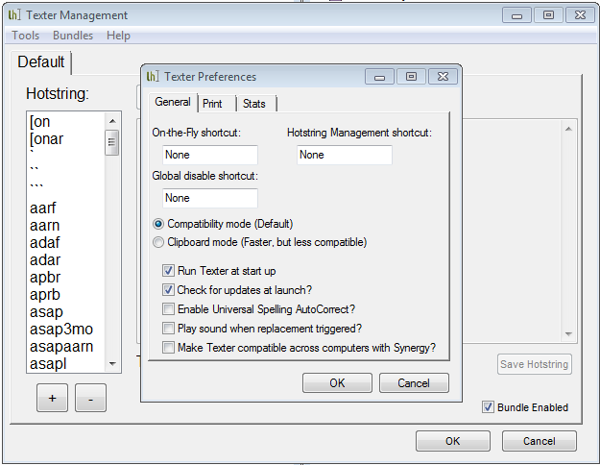

1. Create a test string
2. Demo “Print” feature

Troubleshooting

Texter, if setup properly works very well.

However, there are consistent issues if Texter is not installed as an administrator. These will typically manifest in strings disappearing after having been created or strings re-appearing after having been deleted. This is caused by the fact that Texter cannot make permanent changes to the file that stores the strings so changes only last until the computer is re-started. The solution is to either re-install Texter as an administrator or to manually modify the permissions for the Texter folder.

One other issues is to not use the “instant” trigger for strings. It doesn’t work and can cause issues.

Advanced Features

Texter can do more than simple text replacement. There are several codes that can be entered into strings.

* %c will paste whatever is on the clipboard
* %dl will enter current date as “Friday, December 19, 2014”
* %ds will enter current date as “12/19/2014”
* %t will enter the current time as “10:52 AM”

Texter also has a script mode that allows it to simulate any keyboard press. This allows for the creation of strings that can enter info into the subject of an email and then Tab down to the body of the email and compose that as well. I have included all of my strings in the Texter folder for examples.